

NAME : BISMA FATIMA
CLASS : CS A
ROLL NO: F24605036
COURSE : COMPUTER NETWORK
COURSE CODE : CS-271
LECTURER : SIR NAVEED YOUSAF

LAB TASK 12

Warm-up Task
- Answer each question in your own words
1. What are IP Routing Protocols?
IP routing protocols are standardized methods that routers use to exchange information about network topology. They allow routers to determine the best path for forwarding packets across interconnected networks. Without routing protocols, routers would need static routes, which are inefficient in dynamic or large-scale environments.

2. Different IP Routing Protocols: Working, Pros, and Cons
Protocol | Working | Pros | Cons
RIP (Routing Information Protocol) | Distance-vector; routers periodically share entire routing tables using hop count as metric. | Simple, easy to configure, suitable for small networks. | Limited scalability (max 15 hops), slow convergence.
OSPF (Open Shortest Path First) | Link-state; routers exchange LSAs, build LSDB, and run Dijkstra’s SPF algorithm. | Fast convergence, supports large networks, hierarchical design with areas. | More complex to configure, higher CPU/memory usage.
EIGRP (Enhanced Interior Gateway Routing Protocol) | Hybrid; uses distance-vector with advanced metrics (bandwidth, delay, reliability, load). | Efficient, fast convergence, reduced bandwidth usage. | Proprietary (Cisco-centric), less common in multi-vendor environments.
BGP (Border Gateway Protocol) | Path-vector; used between autonomous systems, relies on policies and attributes. | Scalable, backbone of the internet, policy-based routing. | Complex configuration, slower convergence, requires expertise.

3. How OSPF Maintains a Detailed View of the Network Topology
- OSPF routers generate Link-State Advertisements (LSAs) describing their interfaces, neighbors, and costs.
- LSAs are flooded throughout the OSPF area so every router has identical information.
- Each router stores LSAs in its Link-State Database (LSDB), which represents the full network topology.
- Routers run Dijkstra’s Shortest Path First (SPF) algorithm on the LSDB to calculate the optimal routes.
4. Purpose of OSPF’s Link-State Database (LSDB)
- Acts as a central repository of all LSAs within an OSPF area.
- Ensures synchronization: all routers in the same area maintain identical LSDBs.
- Provides dynamic updates when topology changes, allowing quick convergence.
- Serves as the input for SPF calculations, enabling routers to compute the shortest and most efficient paths.

In Lab Task
By using Drag and Drop draw the topology diagram as Shown below and attach a screenshot of each step.
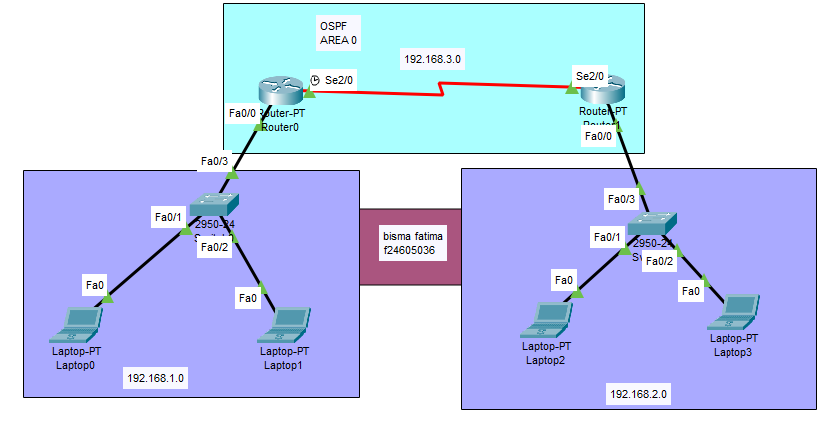
Figure 1. Packet Tracer Topology Diagram

Configuration of OSPF
Step 1: Assign IP Addresses to each network.
Ip configuration of router 0:

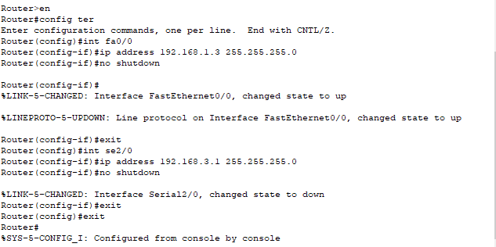

Ip configuration of router 1:
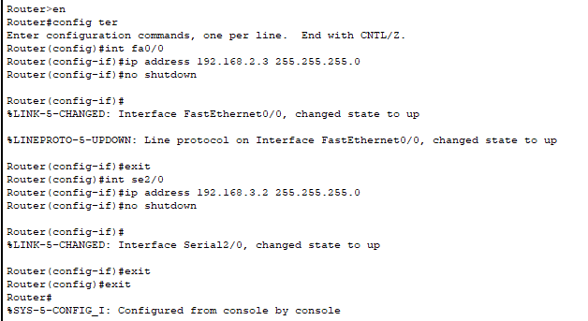
Step2: Configuration of IP Routing Protocol OSPF
- Router 0
- Router(config)#router ospf 1
- Router(config-router)#network 192.168.1.0 0.0.0.255 area 0
- Router(config-router)#network 192.168.3.0 0.0.0.255 area 0
- Router(config-router)#exit
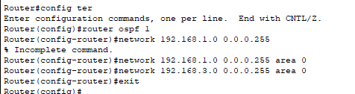
Step3: Repeat step 2 for other Router
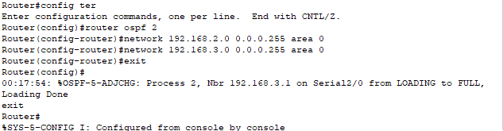
Real time Packet:
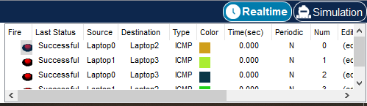
Simulation :
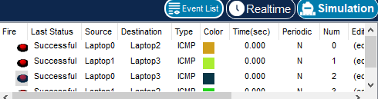
Post Lab Task
By using Drag and Drop draw the topology diagram
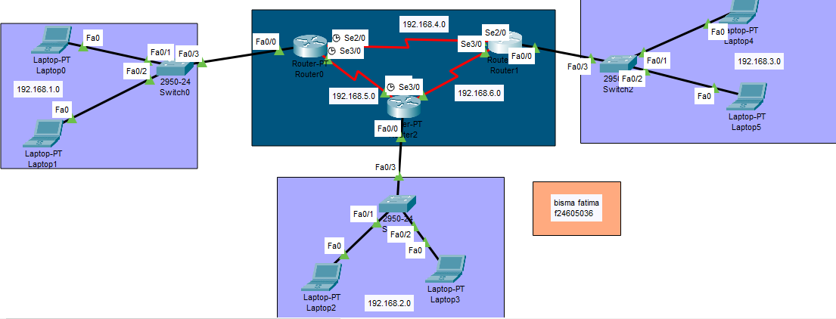
Figure 2. Packet Tracer Topology Diagram
Router ip configuration:
Router 3:
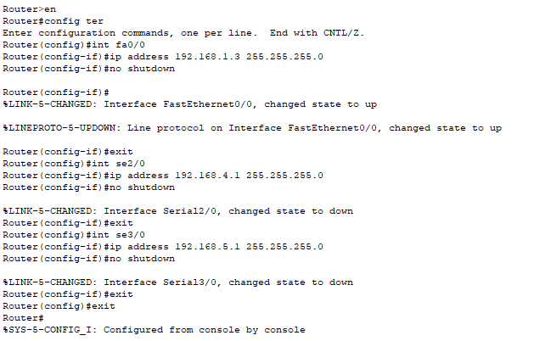
Router 2:
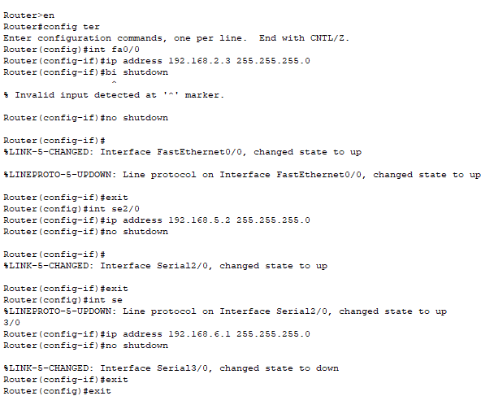

Router 3:

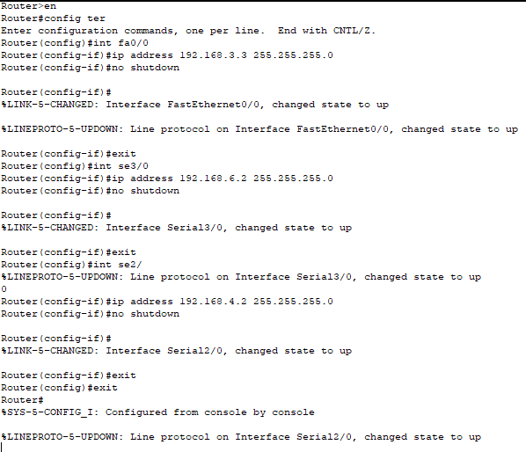

Ospf configuration :
Router 1:
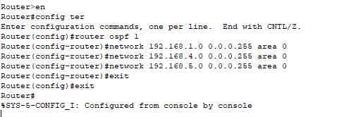
Router 2:

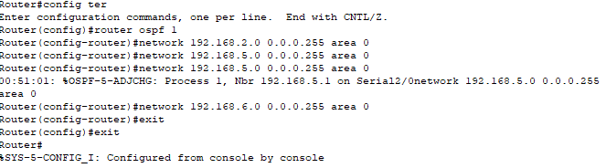
Router 3:
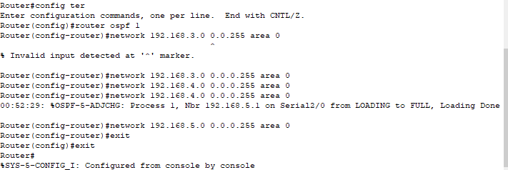

Show ip ospf neighbor
Show ip route ospf
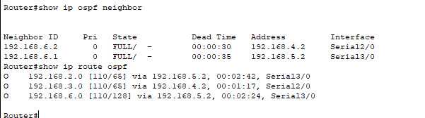

Send packets (Real time).
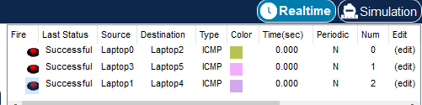
Send packets(Simulation).
